**TRACING OF GROWTH OF THE GOLBAL COMMUNITY- A POPULATION FORECASTING ANALYSIS**

**Milestone 1: Define Problem / Problem Understanding**

**Activity 1: Specify the business problem.**

**Refer Project Description**

**Activity 2: Business requirements.**

**The business requirements for ‘Tracing the growth of global community’ includes**

**1) Accurate data on population growth and demographics for multiple countries and regions.**

**2) The ability to analyze and forecast population growth trends over a specific time period.**

**3) The ability to identify key factors influencing population growth and demographic changes.**

**4) The ability to present the data and analysis in a clear and visually appealing format, such as charts and graphs.**

**5) The ability to integrate the data and analysis with other relevant business information.**

**6) The ability to use the data and analysis to inform strategic decision-making for the company or organization.**

**Activity 3: Literature Survey (Student Will Write)**

**A literature survey is a method of researching existing literature and studies related to a specific topic. In the context of ‘Tracing the growth of a global community’ a literature survey would involve reviewing studies and articles that have been published on the topic of population and demographics, as well as studies specific population increase in cities.**

**The literature survey would include sources such as academic journals, industry reports, and online articles. It would aim to identify key performance indicators (KPIs)**

**Activity 4: Social or Business Impact.**

**Social Impact:**

**Improve the infrastructure and strategies through which the cities could manage the population Business Model/Impact: Improved strategic planning: By understanding population growth trends and demographics, a business can make more informed decisions about where to invest resources and expand operations.**

**Milestone 2: Data Collection & Extraction from Database.**

**Data collection is the process of gathering and measuring information on variables of interest, in an established systematic fashion that enables one to answer stated research questions, test hypotheses, and evaluate outcomes and generate insights from the data.**

**Activity 1: Collect the dataset**

**https://drive.google.com/file/d/1NRrQhbZ8KuzpkvXl9C6MBzFrXg2sE- J6/view?usp=share_link**

**Activity 1.1: Understand the data**



**Milestone 3: Data preparation**

**Activity 1: Prepare the Data for Visualization**

**Preparing the data for visualization involves cleaning the data to remove irrelevant or missing data, transforming the data into a format that can be easily visualized, exploring the data to identify patterns and trends, filtering the data to focus on specific subsets of data, preparing the data for visualization software, and ensuring the data is accurate and complete. This process helps to make the data easily understandable and ready for creating visualizations to gain insights into our analysis**

**Milestone4: Data Visualization.**

**Data visualization is the process of creating graphical representations of data in order to help people understand and explore the information. The goal of data visualization is to make complex data sets more accessible, intuitive, and easier to interpret. By using visual elements such as charts, graphs, and maps, data visualizations can help people quickly identify patterns, trends, and outliers in the data.**

**Activity 1: No of Unique Visualizations.**

**The number of unique visualizations that can be created with a given dataset. Some common types of visualizations that can be used to analyze the population growth in the cities, include bar charts, line charts, heat maps, scatter plots, pie charts,Maps etc. These visualizations can be used to compare performance, track changes over time, show distribution, and relationships between variables**

**Activity 1.1: Population records by type of countries**

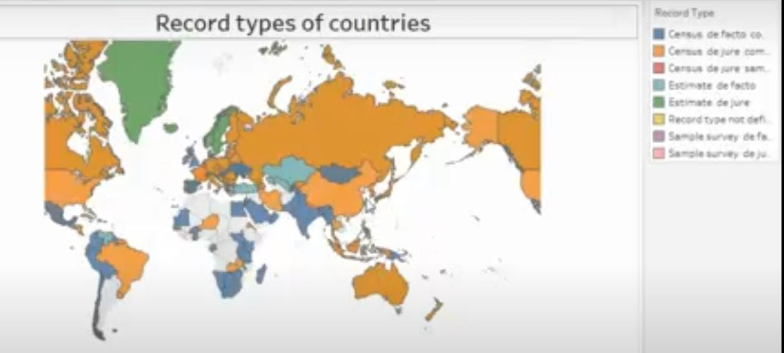

**Activity 1.2: Population trends over the years**

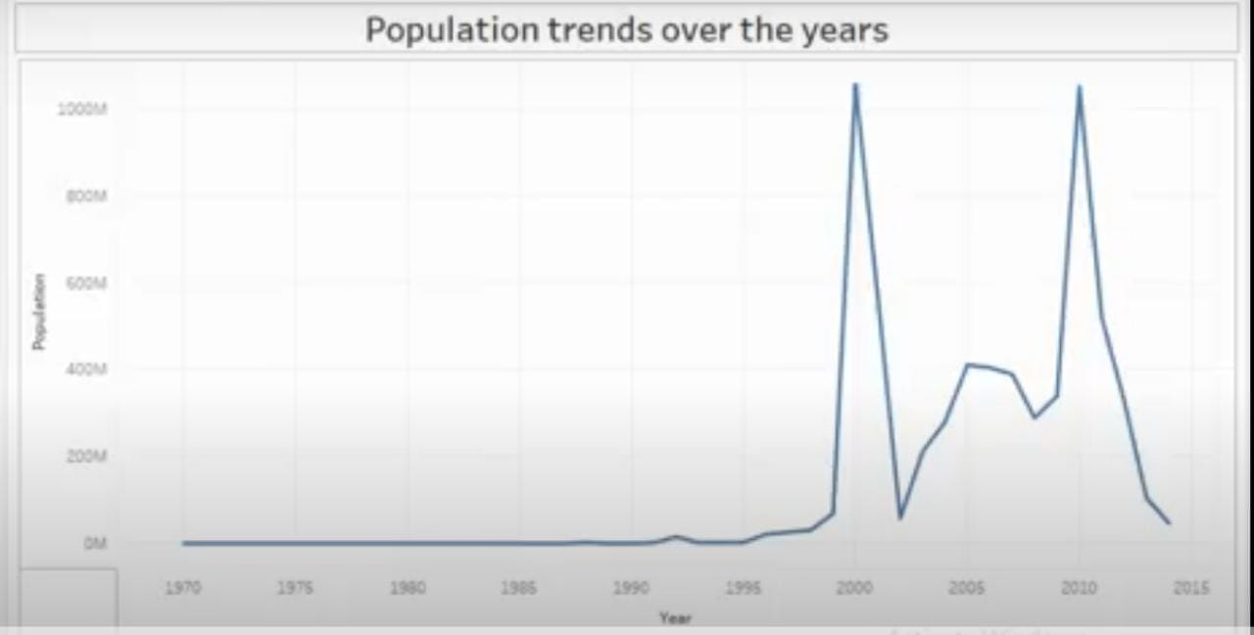

**Activity 1.3: Population trends over the years by sex**

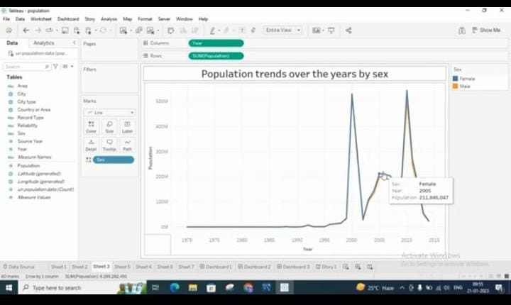

**Activity:1.4: Cities with highest average populations**

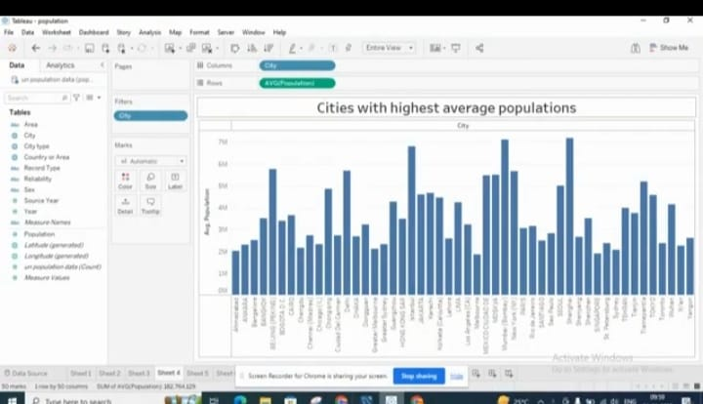

**Activity:1.5**

**Countries with highest average population from 200-2014**

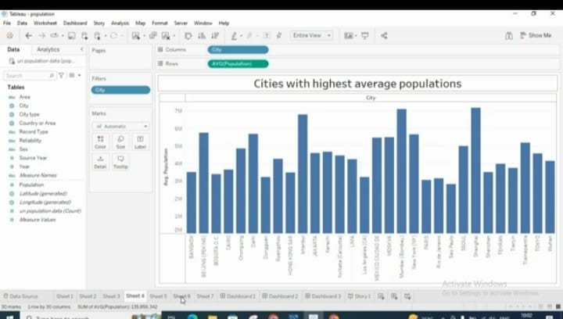

**Activity 1.6: Population by city type**

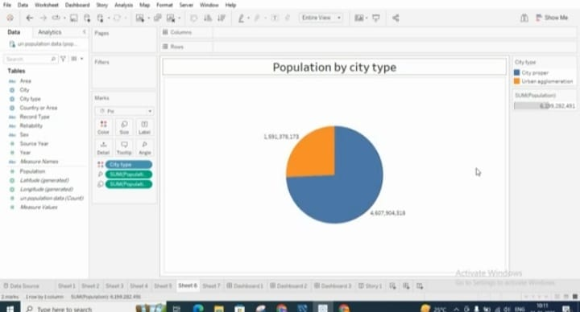

**Activity 1.7: Population of citied by year**

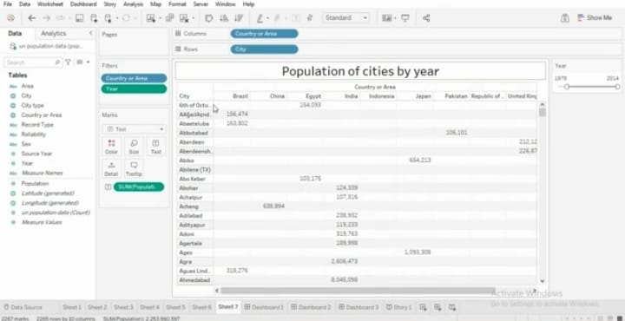

**Milestone 5:Dashboard**

**A dashboard is a graphical user interface (GUI) that displays information and data in an organized, easy-to-read format. Dashboards are often used to provide real-time monitoring and analysis of data, and are typically designed for a specific purpose or use case. Dashboards can be used in a variety of settings, such as business, finance, manufacturing, healthcare, and many other industries. They can be used to track key performance indicators (KPIs), monitor performance metrics, and display data in the form of charts, graphs, and tables.**

**Activity :1- Responsive and Design of Dashboard**

**The responsiveness and design of a dashboard for analyzing population growth in the cities is crucial to ensure that the information is easily understandable and actionable. Key considerations for designing a responsive and effective dashboard include user-centered design, clear and concise information, interactivity, data-driven approach, accessibility, customization, and security. The goal is to create a dashboard that is user-friendly, interactive, and data-driven, providing actionable insights on the population demographics of different cities across the world.**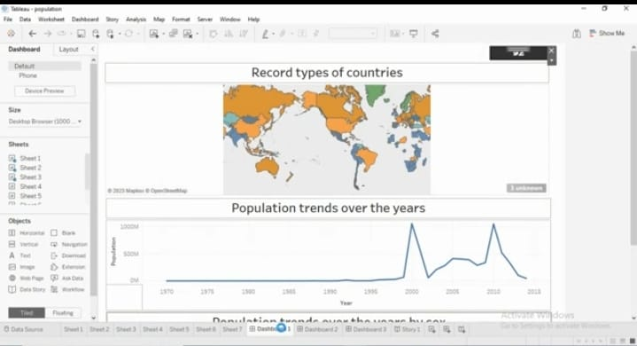

**Once you have created views on different sheets in Tableau, you can pull them into a dashboard.**

**.**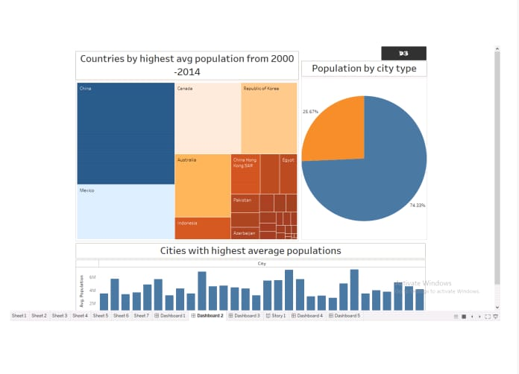

**Milestone 6: Story**

**A data story is a way of presenting data and analysis in a narrative format, with the goal of making the information more engaging and easier to understand. A data story typically includes a clear introduction that sets the stage and explains the context for the data, a body that presents the data and analysis in a logical and systematic way, and a conclusion that summarizes the key findings and highlights their implications. Data stories can be told using a variety of mediums, such as reports, presentations, interactive visualizations, and videos.**

**Activity:1- No of Scenes of Story**

**The number of scenes in a storyboard for a data visualization analysis of population growth across the cities will depend on the complexity of the analysis and the specific insights that are trying to be conveyed. A storyboard is a visual representation of the data analysis process and it breaks down the analysis into a series of steps or scenes.**



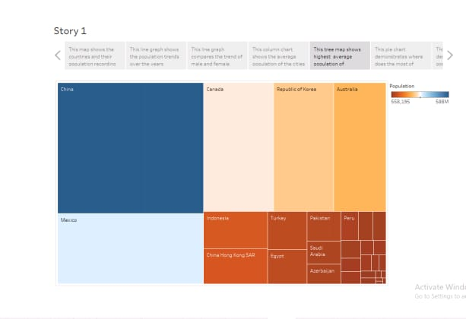

**Milestone 7: Performance Testing**

**Activity 1: Amount of Data Rendered to DB.**

**\* The amount of data that is rendered to a database depends on the size of the dataset and the capacity of the database to store and retrieve data.**

**\* Open the MySQL Workbench, go to the database then click to expand the tables, select the table and click on (i) button to get the information related to table such as column count,table rows etc.**

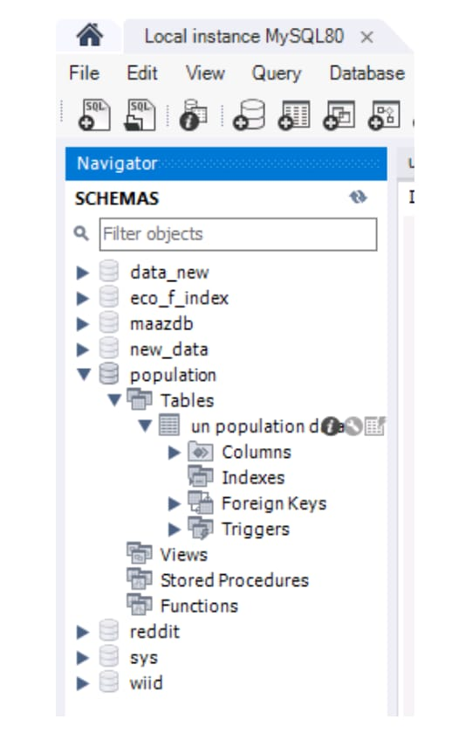

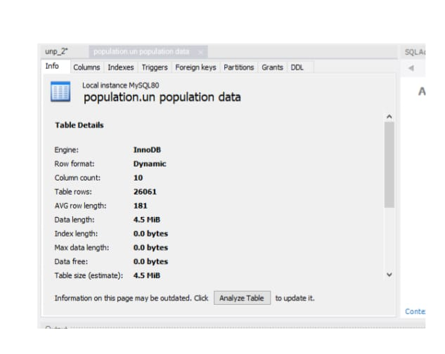

**Activity2: Utlilization of Data Filters**

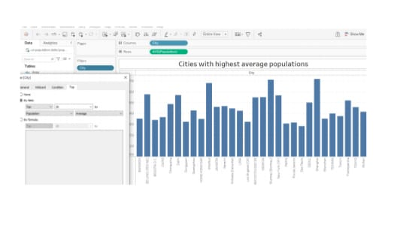

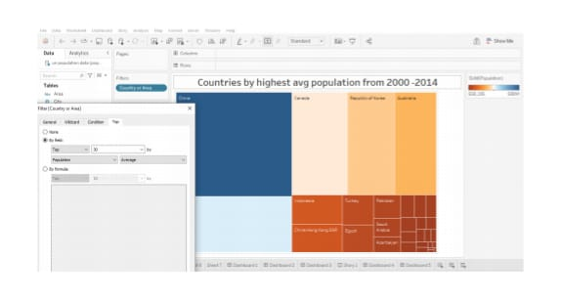

**Activity 3: No of calculation Fields**

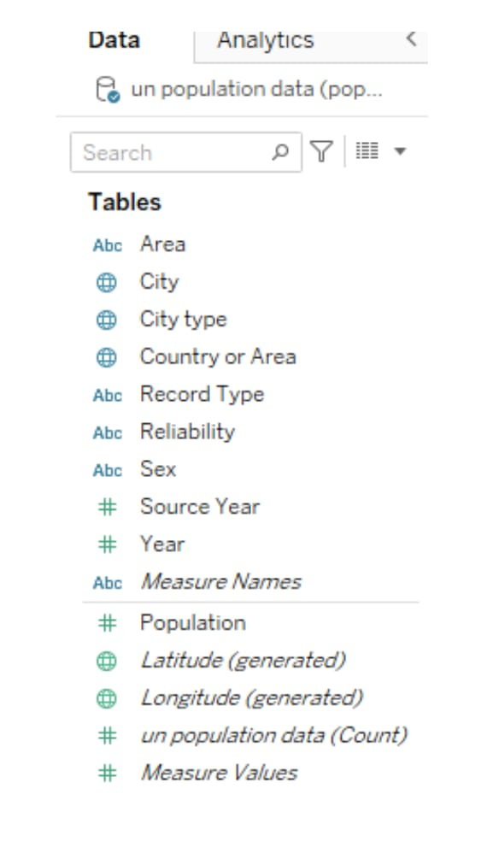

**Activity 4:**

**No of Visualizations/ Graphs**

**1. Population record types of countries**

**2. Population trends over the years**

**3. Population trends over the years by sex**

**4. Cities with highest average population**

**5. Countries with highest avg population from 2000 – 2014**

**6. Population by city type**

**7. Population of cities by year**

**Milestone 8: Web integration**

**Publishing helps us to track and monitor key performance metrics, to communicate results and progress. help a publisher stay informed, make better decisions, and communicate their performance to others.**

**Publishing dashboard and reports to tableau public**

**Step 1: Go to Dashboard/story, click on share button on the top ribbon**

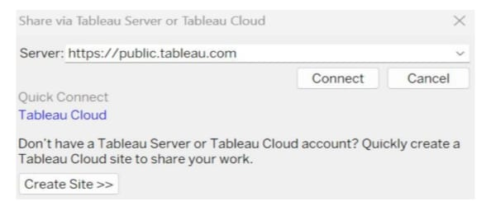

**Give the server address of your tableau public account**

**Step 2 :Ones you click on connect it will ask you for tableau public user name and password**

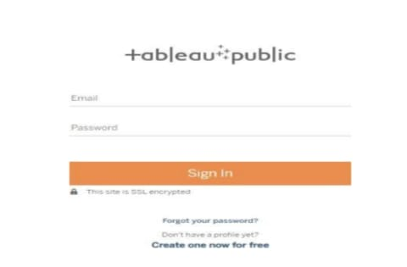

**Note: While publishing the visualization to the public, the respective sheet will get published when you click on share option**

**Activity 1: Dashboard and Story embed with UI With Flask**

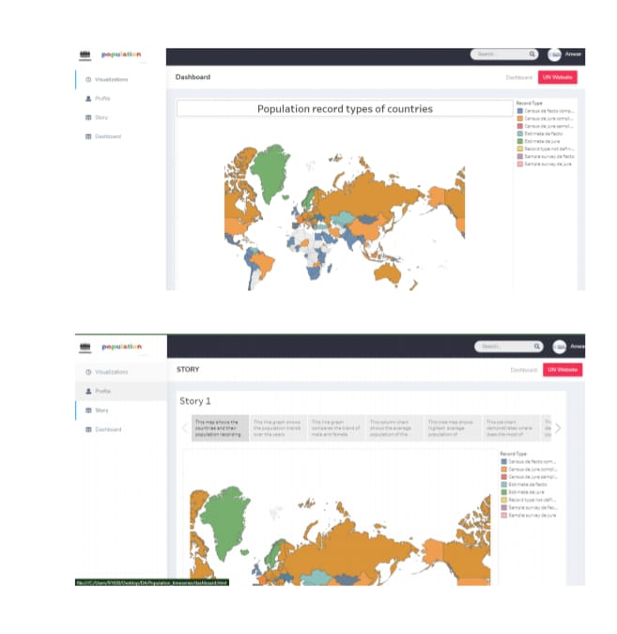

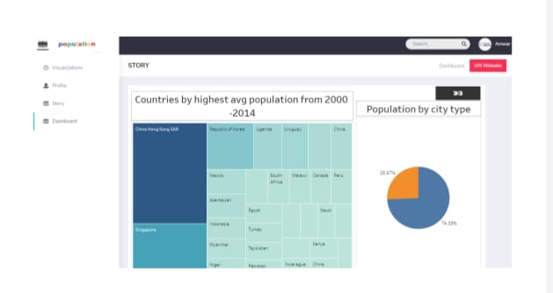

**Milestone 9: Project Demonstration & Documentation**

**Below mentioned deliverables to be submitted along with other deliverables**

**Activity 1:- Record explanation Video for project end to end solution**

**Activity 2:- Project Documentation-Step by step project development procedure**